1. **Jobber land Installation Steps :-**

**Step 1:-** Goes to **Jobberland folder** then open **libs** folder then edit **config.php** file.

See below screenshot.

**Jobberland folder** -**> libs** **-> config.php**

1. Change database name, username, password to our database name, username, password

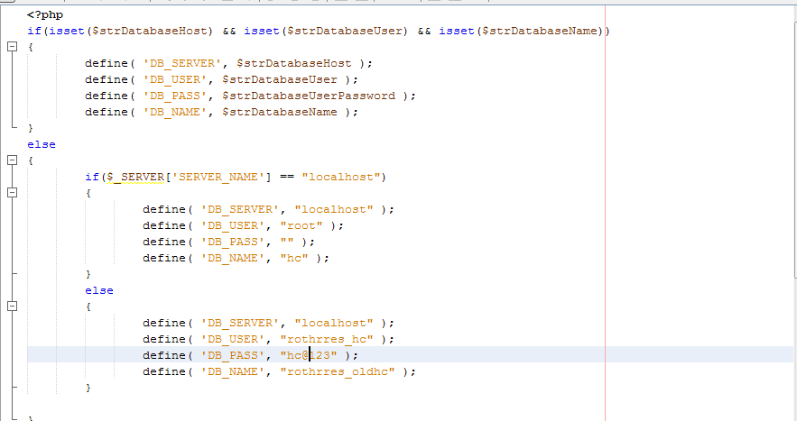

**Step 2:-** Go to **Jobberland folder** then open **libs** folder then edit **initialise.php** file.

See below screenshot.

**Jobberland folder** -**> libs** **-> initialise.php**

1. Change database name, username, password to our database name, username, password

